**Control-M Agent & Control-M Managed File Transfer Agent (AFT) Plugin Installation Steps in AIX**

1. Create 5 GB Filesystem /opt/ctm. It should be owned by svczena:zenagrp

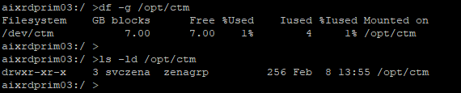

wget <http://dwauslsatc01.app.dev.hcscint.net/pub/ks/depot/ctm/java-11-openjdk-11.0.17.0.8-2.portable.jre.el.x86_64.tar.xz>

1. Copy the Installation tar archives in /opt/ctm.

DRKAI.9.0.19.200_AIX – This provides Control-M agent install binaries

DRAFT.9.0.19.200_AIX – This provided Control-M AFT Plugin install binaries

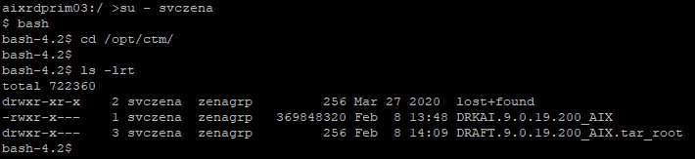

1. First install Control-M agent. Extract the archive file as following.

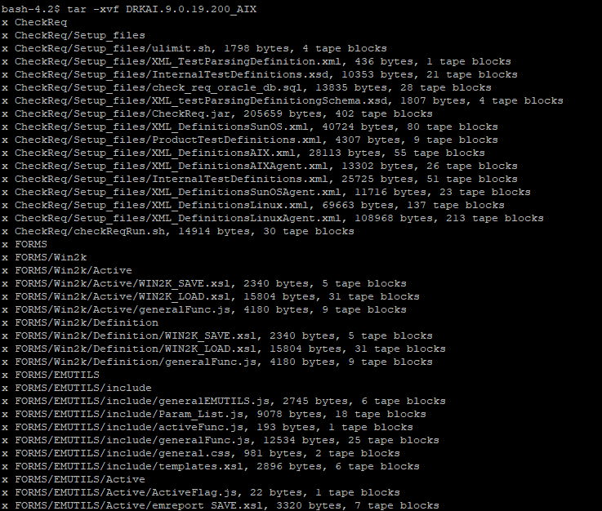

1. Files and Folders are extracted under /opt/ctm. Check all files and folders shows up.

To Install the Control-M Agent run “./setup.sh” as following. Follow the screenshot to enter the command/options on being prompted for User Input.

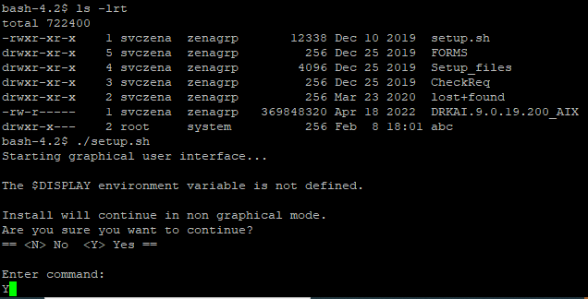

1. On License Agreement, first press ‘S’ and then ‘Y’.

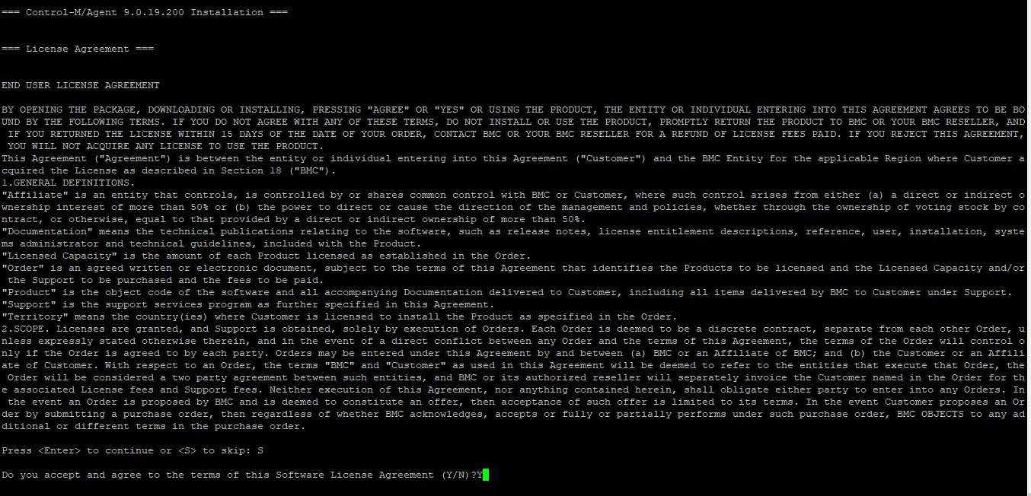

1. Press ‘1’ to update the Primary Control-M/Server host.

Press ‘2’ to update the Authorized Control-M/Server hosts.

**DEV**

**Primary:** dwauswapp01.adhcscdev.net

**Authorized:** dwauswapp01.adhcscdev.net|dwauswapp02.adhcscdev.net

**TEST**

**Primary:** twauswapp02.adhcsctst.net

**Authorized:** twauswapp02.adhcsctst.net|twauswapp03.adhcsctst.net

**PROD**

**Primary:** pwauswapp02.adhcscint.net

**Authorized:** pwauswapp02.adhcscint.net|pwauswapp03.adhcscint.net

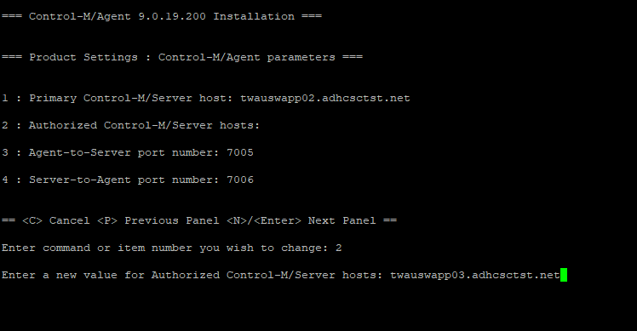

1. Once all options are filled in, press ‘Enter’ to continue the installation.

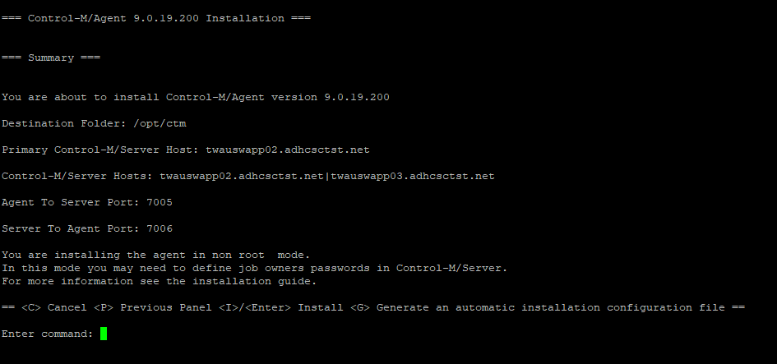

1. Once Installation completes successfully, run the command ‘ps -ef | grep ctm” to verify Control-M process is running

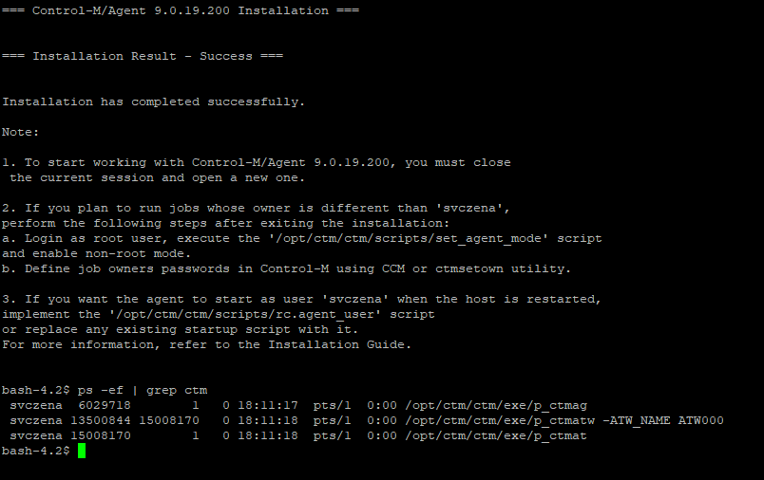

1. CTM agent is installed by ‘svczena’ user. So as ‘svczena’ user, run “/opt/ctm/ctm/scripts/ag_diag_comm” to verify Control-M/Agent Comm
2. To install Control-M Managed File Transfer Agent (AFT) Plugin, first stop Control-M agent using “/opt/ctm/ctm/scripts/shut-ag” command.

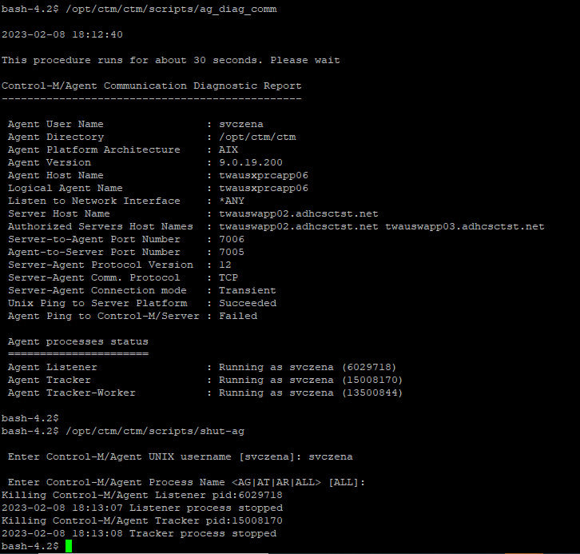

1. Extract DRAFT.9.0.19.200.tar file inside /opt/ctm using the tar command.

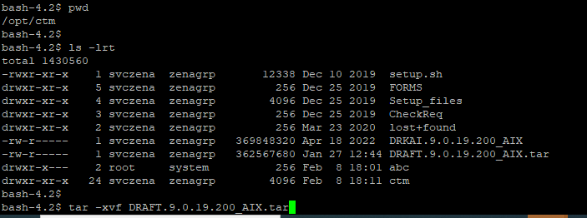

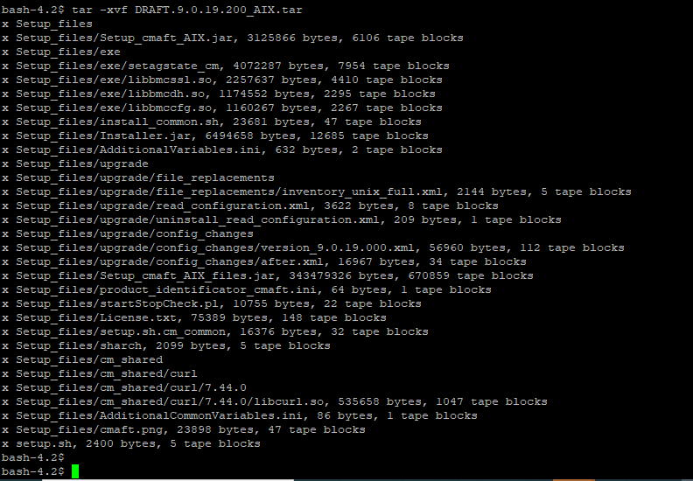

1. Run “./setup.sh” to install AFT Plugin. Enter ‘Y’ when prompted for User input.

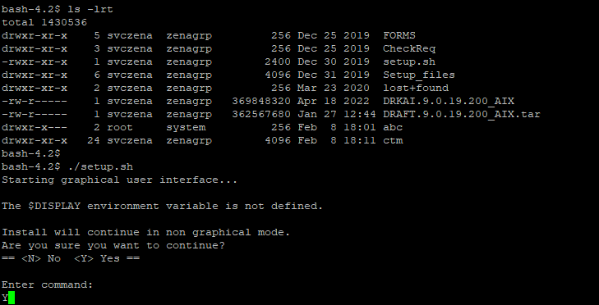

1. On License Agreement, first press ‘S’ and then ‘Y’.

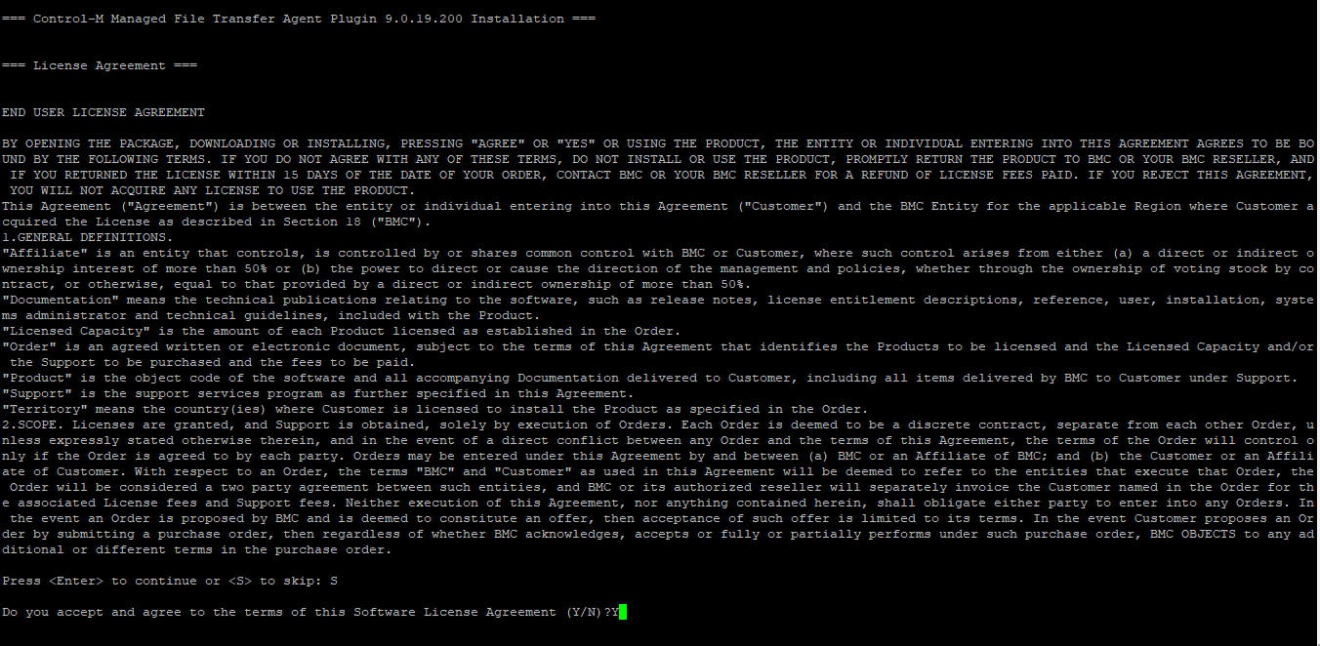

1. Press ‘Enter’ to install Control-M Managed File Transfer Agent (AFT) Plugin.

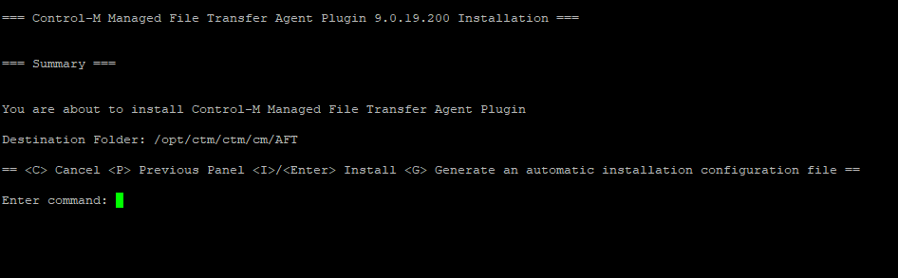

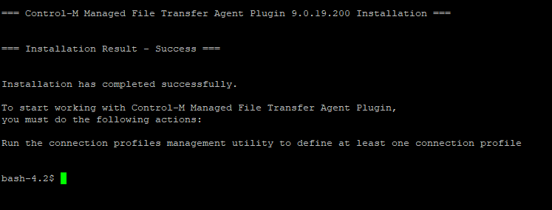

1. Check the home directory of the installation user. Here ‘svczena’ is the installation user and its home directory is /opt/zena. We can find perl libraries in the install user home directory.
2. Since the install folder (/opt/ctm) is different from home directory (/opt/zena) of install user, we will create a softlink to perl libraries in install directory as ‘svczena’ user.

cd /opt/ctm

ln -s /opt/zena/bmcperl bmcperl

ln -s /opt/zena/installed-versions.txt installed-versions.txt

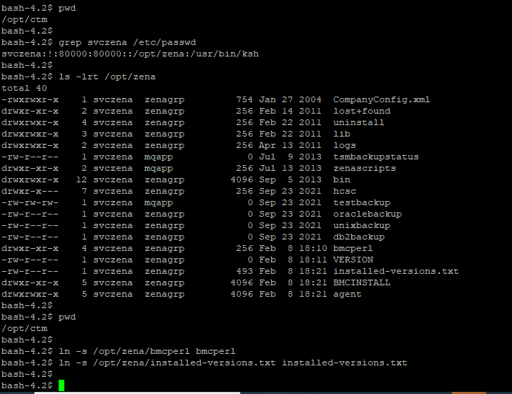

1. Start Control-M agent using “/opt/ctm/ctm/scripts/start-ag” as ‘svczena’ user.

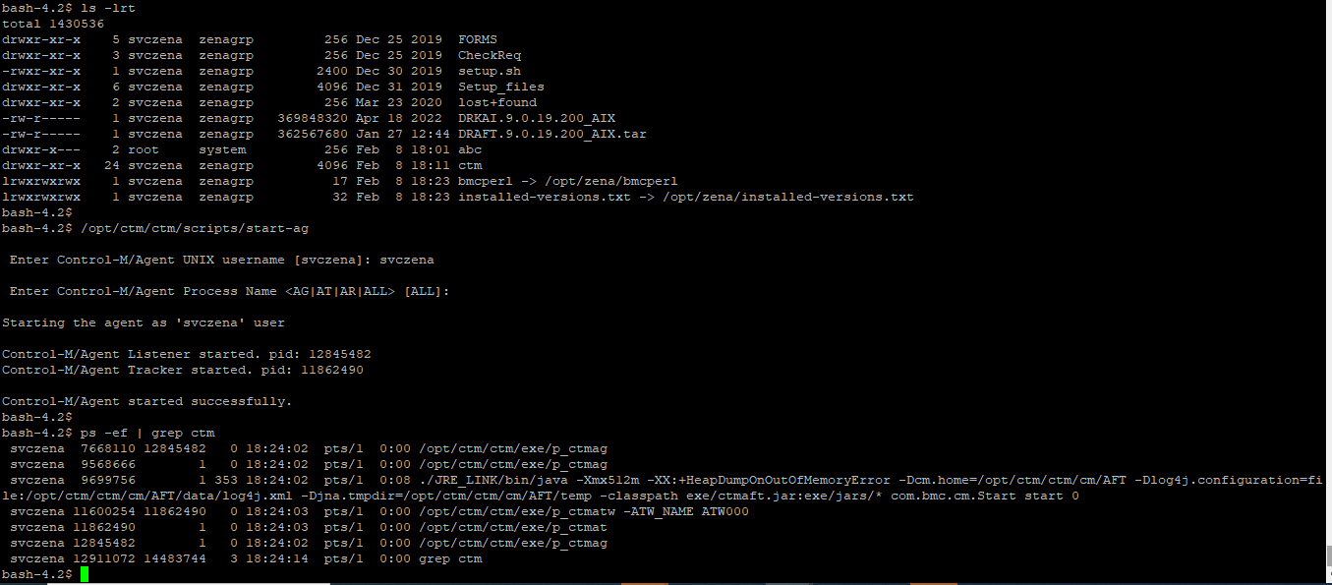

1. Run “ag_diag_comm” to get the Control-M/Agent Communication Diagnostic Report.

